**University of Michigan – Dearborn**

**CIS 150 – Computer Science 1**

**Lab# 6**

Quan Le

[lmmquan@umich.edu](mailto:lmmquan@umich.edu)

February 20, 2024

**Table Content**

Contents

Question 1 3

Test Cases 3

Source Code 3

Screenshots 3

Question 2 5

Test Cases 5

Source Code 5

Screenshots 5

Question 3 6

Test Cases 6

Source Code 7

Screenshots 7

# Question 1

## Test Cases

|  |  |  |  |  |  |  |
| --- | --- | --- | --- | --- | --- | --- |
| Test # | Valid / Invalid Data | Description of test | Input Value | Expected Output | Actual Output | Test Pass / Fail |
| 1 | Valid | Input 2, -5 | N = 2  N = -5 | sum = 3  average = 1 | Sum from 0 to 2 is 3  Average is 1  Exiting the program | Pass |
| 2 | Valid | Input -5 | N = -5 | Exiting the program | Exiting the program | Pass |
| 3 | Valid | Input 5,6, -10 | N = 5  N = 6  N = -10 | sum = 15  average = 2  sum = 21  average = 3 | Sum from 0 to 5 is 15  Average is 2  Sum from 0 to 6 is 21  Average is 3  Exiting the program | Pass |
| 4 | Invalid | Input * |  | Exit the program immediately | Exit the program immediately | Pass |

## Source Code

The source code for this question has been uploaded to Canvas as lab6q1.cpp.

## Screenshots

Test Case 1:

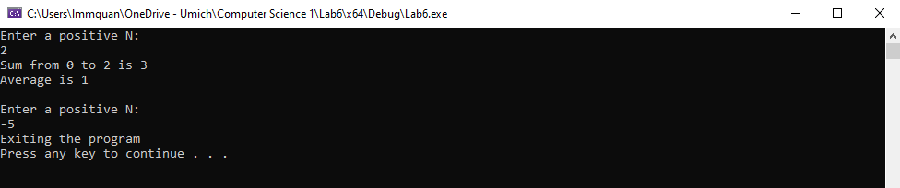

Test Case 2:

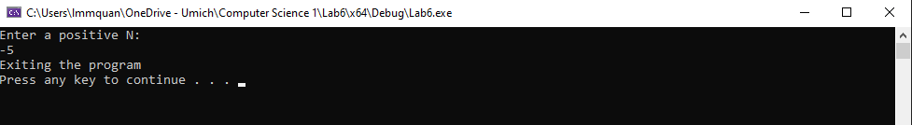

Test Case 3:

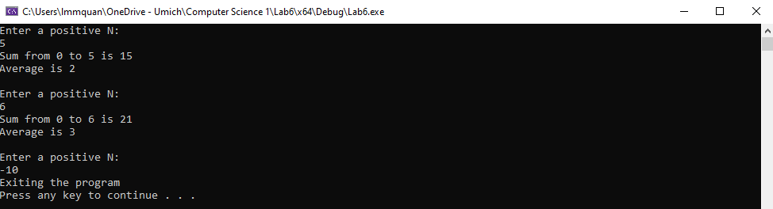

Test Case 4:

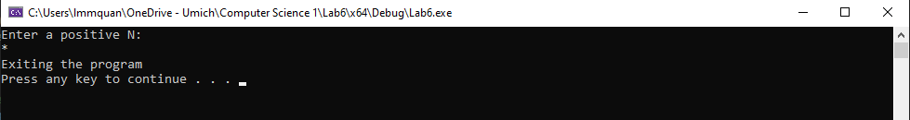

# Question 2

## Test Cases

|  |  |  |  |  |  |  |
| --- | --- | --- | --- | --- | --- | --- |
| Test # | Valid / Invalid Data | Description of test | Input Value | Expected Output | Actual Output | Test Pass / Fail |
| 1 | Valid | Input @, 3, 4 | symbol = ‘@’  width = 3  height = 4 | @@@  @  @  @@@ | @@@  @  @  @@@ | Pass |
| 2 | Valid | Input $, 5, 5 | symbol = ‘$’  width = 5  height = 5 | $$$$$  $  $  $  $$$$$ | $$$$$  $  $  $  $$$$$ | Pass |
| 3 | Invalid | Input !, 1, 1 | symbol = ‘!’  width = 1  height = 1 | Can’t produce a C shape | Can’t produce a C shape | Pass |
| 4 | Valid | Input =, 4, 6 | symbol = ‘=’  width = 4  height = 6 | ====  =  =  =  =  ==== | ====  =  =  =  =  ==== | Pass |

## Source Code

The source code for this question has been uploaded to Canvas as lab6q2.cpp.

## Screenshots

Test Case 1:

Test Case 2:

Test Case 3:

Test Case 4:

# Question 3

## Test Cases

|  |  |  |  |  |  |  |
| --- | --- | --- | --- | --- | --- | --- |
| Test # | Valid / Invalid Data | Description of test | Input Value | Expected Output | Actual Output | Test Pass / Fail |
| 1 | Valid | Number of integers to input is 5  Input 9, -5 , 3, 7, 1 | N = 5  input = 9  input = -5  input = 3  input = 7  input = 1 | Highest value is: 9  Lowest value is: -5 | Highest value is: 9  Lowest value is: -5 | Pass |
| 2 | Valid | Number of integers to input is 2  Input 1, 3 | N = 2  input = 1  input = 3 | Highest value is: 3  Lowest value is: 1 | Highest value is: 3  Lowest value is: 1 | Pass |
| 3 | Valid | Number of integers to input is 1  Input 0 | N = 1  input = 0 | Highest value is: 0  Lowest value is: 0 | Highest value is: 0  Lowest value is: 0 | Pass |
| 4 | Invalid | Number of integers to input is a negative number | N = -1 | You must enter an integer greater than 0 | You must enter an integer greater than 0 | Pass |

## Source Code

The source code for this question has been uploaded to Canvas as lab6q3.cpp.

## Screenshots

Test Case 1:

Test Case 2:

Test Case 3:

Test Case 4:

